Resource Management POC

Technology used:
Spring Framework, Activiti Framework (5.16.4), SQL DB on bluemix and Bluemix cloud.

Requirement:
The requirement is to create a workflow which would start with the client requirement for a human resource and end with assigning a suitable candidate. The steps are mentioned below:
- A Client requirement is received.
- The process is Started.
- Anyone with management role will get a task in his/her queue to create the client requirement in the system. The task is completed.
- The task will appear in pmo group. User belonging to PMO group will create a PMP ID and complete the task.
- The task will be queued up in rcm group, who will provide a suitable candidate for that requirement and complete from their end.
- The task will appear in technical group who will perform internal technical discussion. The Candidate may be a select or a reject. If Candidate is selected, he will have to go for a client interview. If he is rejected, Then go to Step 5.
- After the client interview, Management team will get feedback whether he is selected or rejected. Manager will update the task. If candidate is rejected, Go to Step 5. If selected, It will go to RCM team.
- RCM team will inform the candidate and process ends.
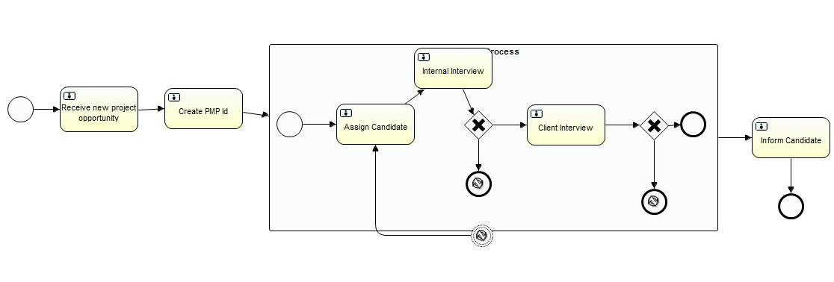
User Instructions:
Below are the instructions to test this flow.
Groups created for Demo:
- Management
- Pmo
- Rcm
- Technical

User Details created for demo:
- manager/manager belonging to management group.
- pmouser/pmouser belonging to pmo group
- rcmuser/rcmuser belonging to rcm group
- techteam/techteam belonging to technical group

Steps with Screenshots:
1: Access http://activitybpm.mybluemix.net/ and you will see the login screen. Login with manager/manager
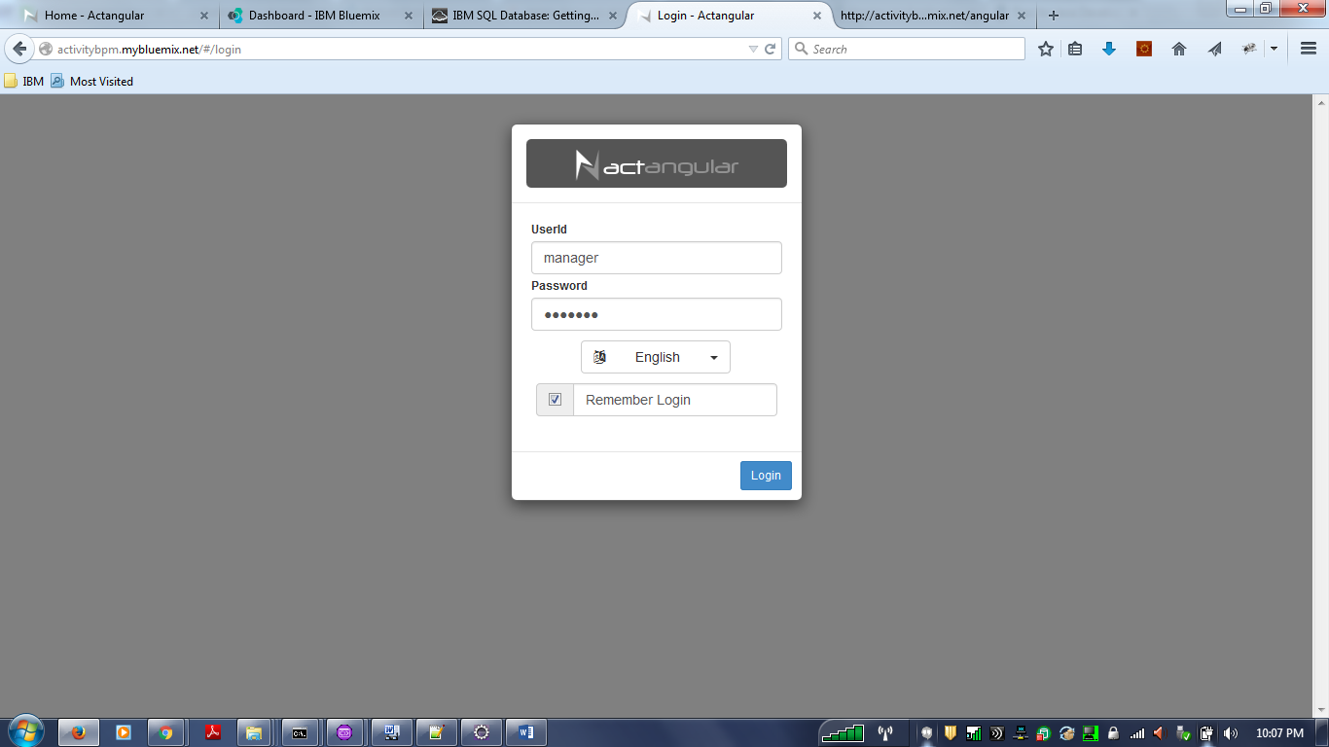

2: Once you see the home screen, Click on the definitions (highlighted in blue). The process should appear. You should click on the play button on the right. (Highlighted in red ). This action will start the process and there will be a task in management queue.
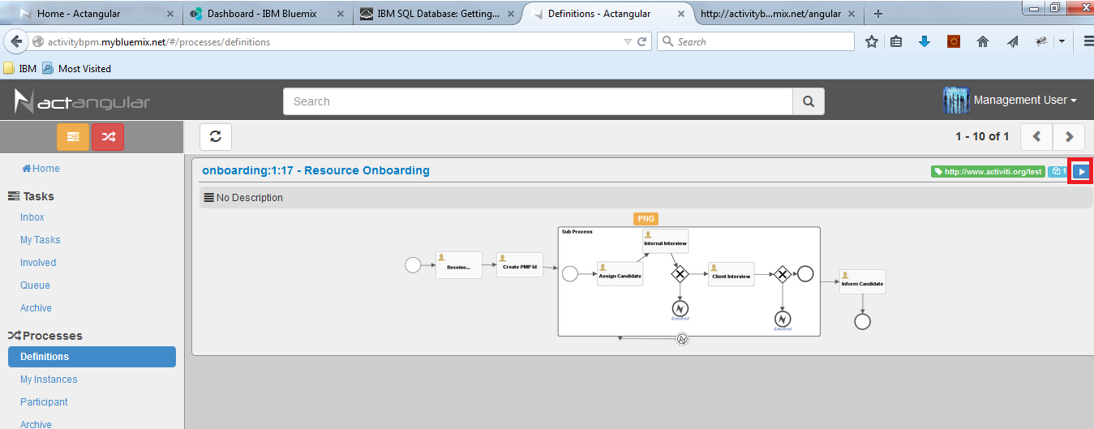

3: Since you have logged in as manager, You can check your queue and see a task for you. Click on the queue link. This can be viewed by all the users who are in management group. For our POC we have only one user (manager) who is in demo group.
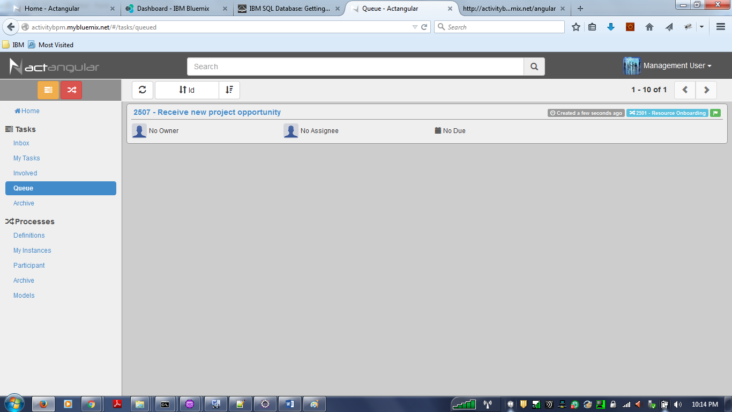

4: Click on the task link. And click on the right hand side download icon (Highlighted in red rectangle) which would bring the task in your inbox.
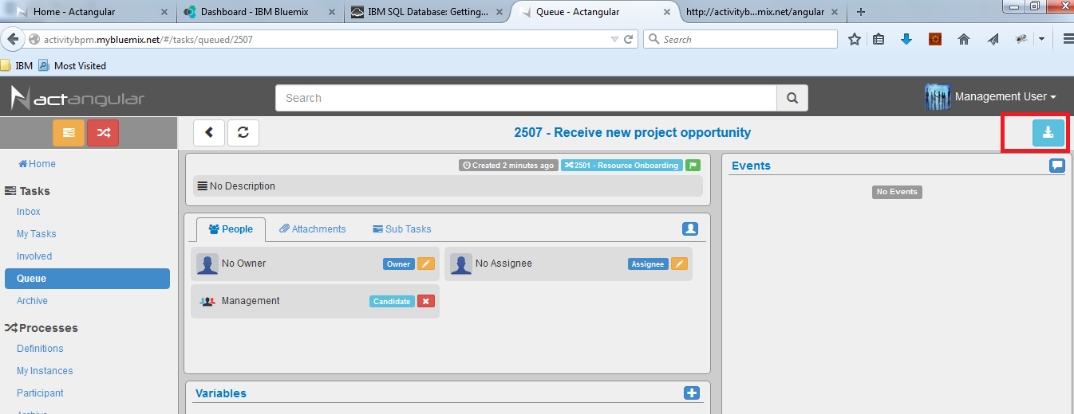

4: Now you will see this task in Inbox. Click on Inbox and then click on task link
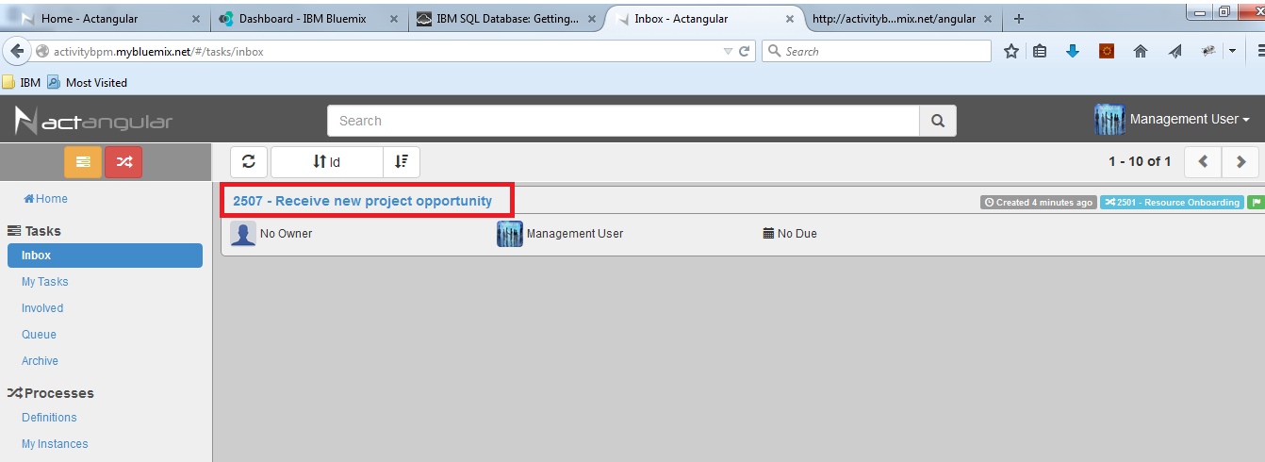

5: Now click on the icon on the right side to complete the task. This will open up a form to get some data like Requirement and the team as shown in the image below. Fill the Requirement and the Project Team and click OK. The task should disappear from he queue.
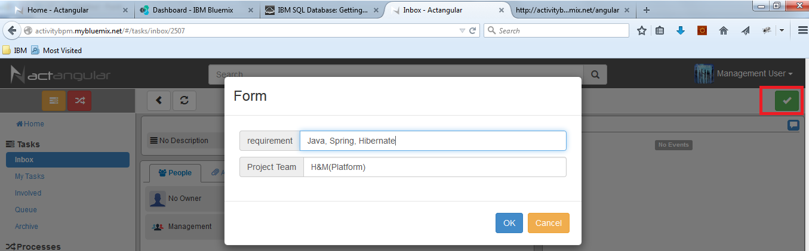
Next Action to be taken by PMO team:
1: Login with pmouser/pmouser and go to Queue. A task should appear there.
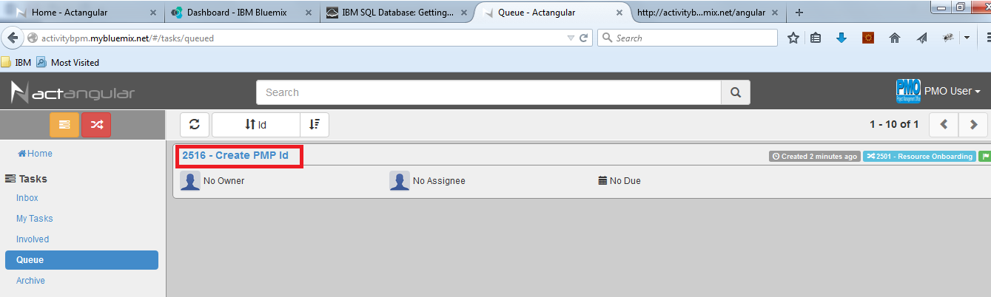

2: Click on the task link and claim. The task will move to Inbox.
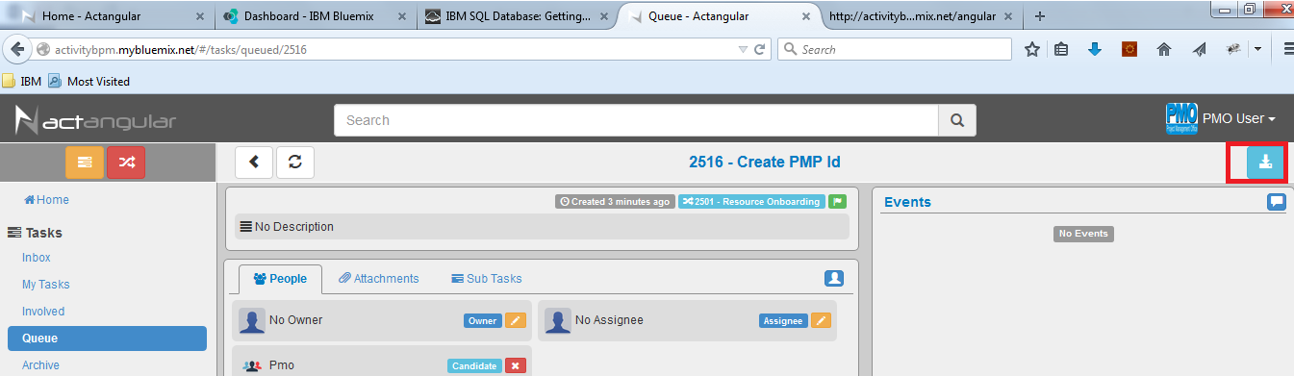

3: Go to Inbox and work on the task.When you click to complete the task, It will ask for PMP ID. Provide the PMP ID and click OK. The task will go to RCM team queue.
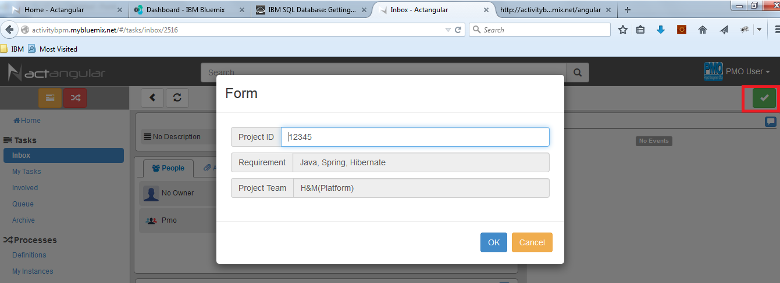

Next Action to be taken by RCM team:
1: Login with rcmuser/rcmuser, Go to the queue and claim the task as done with previous users. Once claimed, It will appear in the Inbox. Go to Inbox and click on the task link to complete. When you try to complete the task, It will ask for candidate’s details like shown in the image below. Provide the details and click OK. The task will go to technical team group for internal interview.
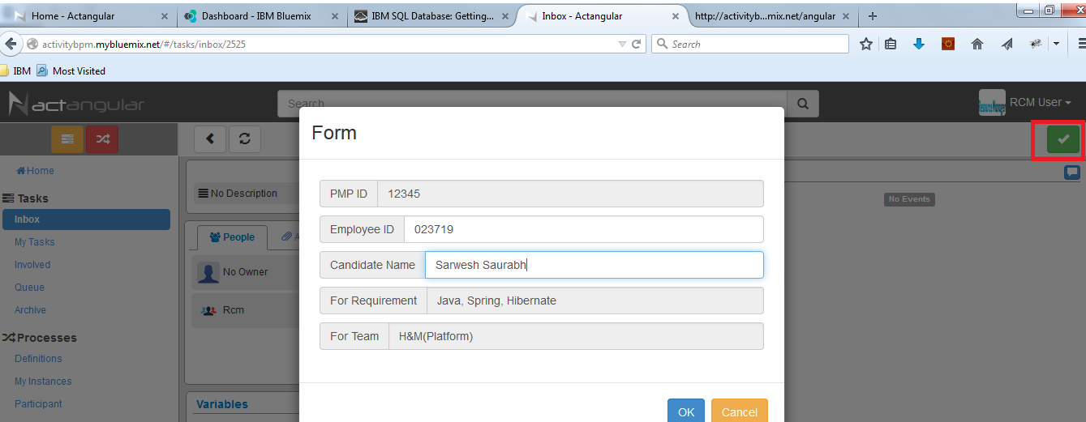

Next Action to be taken by RCM team:
1: After the tech interview is done, Login with techteam/techteam. Go to the queue, Claim the task and Go to the Inbox and click on the task. And complete the task. Here you can choose yes for selected and no for rejected. If candidate is rejected, The task will go to RCM team who will provide another candidate. If selected, The candidate will go through Client interview.
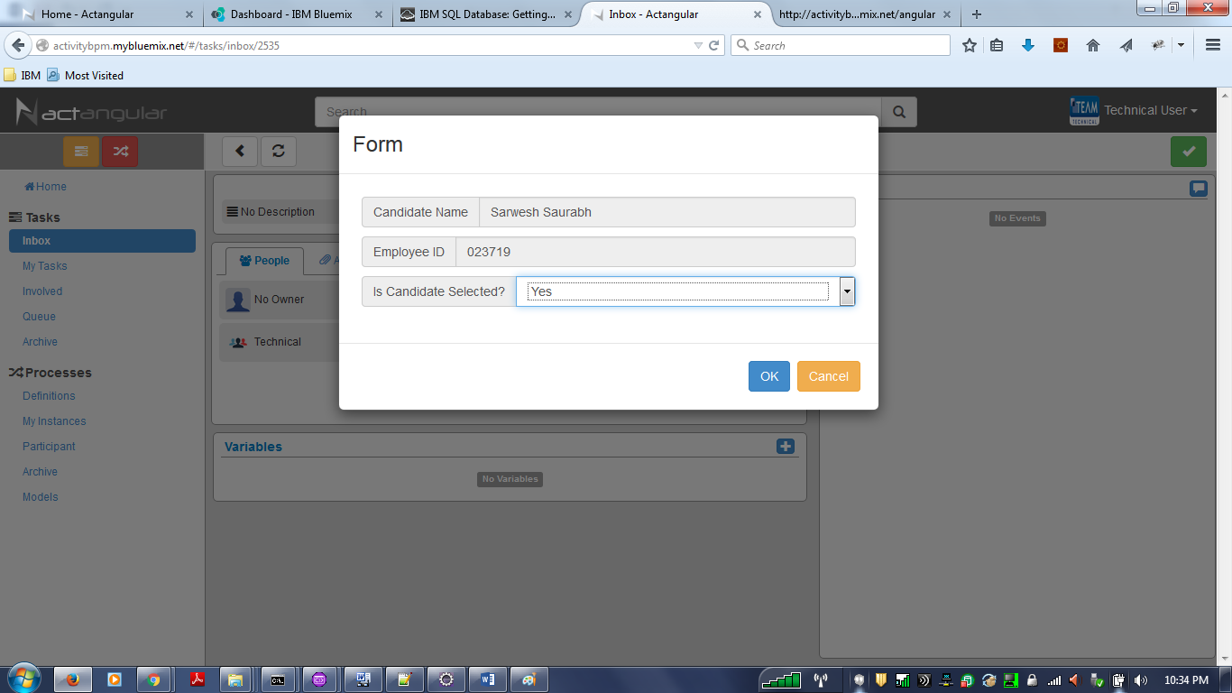

Next Action to be taken by RCM team:
1: Client feedback will come to Manager. So once the feedback is received, Manager will complete the task from queue. Same process to be followed for claiming and completing the task. If selected, Task will go to PMO team who will inform candidate, If no then It wll go to RCM team who will have to send another candidate.
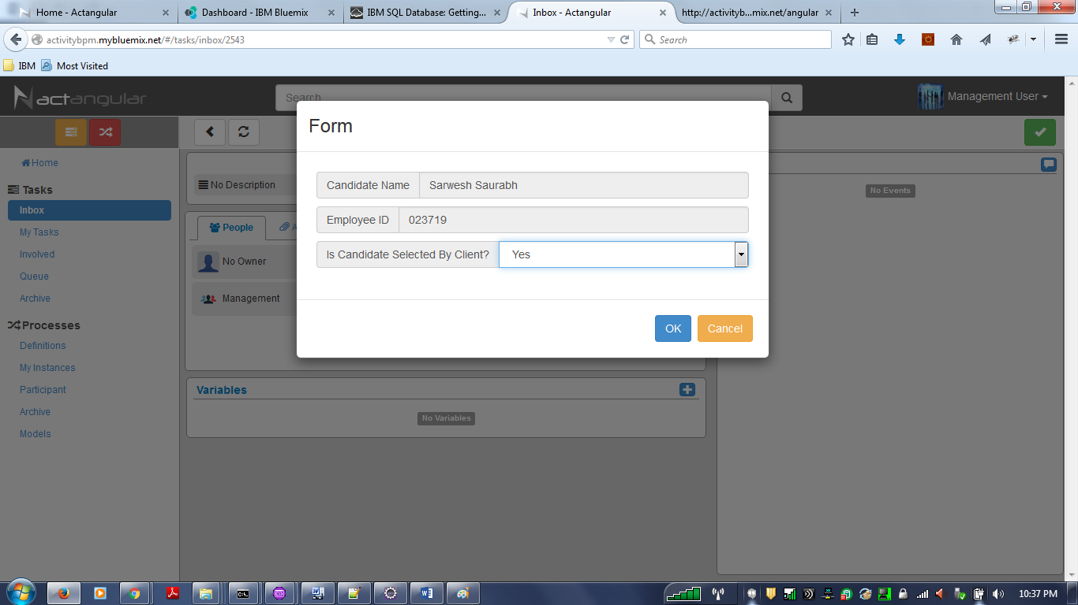
If everything goes fine, PMO team can inform candidate and the process is complete. I had tested this for candidate rejection scenario as well. Feel free to test the flows.

This is a simple POC which has a lot for improvement. Its better to get these tested by different users(like PMO, Managers, technical team members etc) and get their feedback.
History not appearing in archive on bluemix: Following query creating problem and this is basically related to bluemix tablespace explained in link below.
https://developer.ibm.com/answers/questions/19017/db2-temporary-table-space-bluemix.html

SELECT SUB.* FROM ( select distinct TEMPRES_ID_ as ID_, TEMPRES_BUSINESS_KEY_ as BUSINESS_KEY_, TEMPRES_PROC_DEF_ID_ as PROC_DEF_ID_, TEMPRES_START_TIME_ as START_TIME_, TEMPRES_END_TIME_ as END_TIME_, TEMPRES_DURATION_ as DURATION_, TEMPRES_START_USER_ID_ as START_USER_ID_, TEMPRES_START_ACT_ID_ as START_ACT_ID_, TEMPRES_END_ACT_ID_ as END_ACT_ID_, TEMPRES_SUPER_PROCESS_INSTANCE_ID_ as SUPER_PROCESS_INSTANCE_ID_, TEMPRES_DELETE_REASON_ as DELETE_REASON_, TEMPVAR_ID_ as VAR_ID_, TEMPVAR_NAME_ as VAR_NAME_, TEMPVAR_TYPE_ as VAR_TYPE_, TEMPVAR_REV_ as VAR_REV_, TEMPVAR_PROC_INST_ID_ as VAR_PROC_INST_ID_, TEMPVAR_EXECUTION_ID_ as VAR_EXECUTION_ID_, TEMPVAR_TASK_ID_ as VAR_TASK_ID_, TEMPVAR_BYTEARRAY_ID_ as VAR_BYTEARRAY_ID_, TEMPVAR_DOUBLE_ as VAR_DOUBLE_, TEMPVAR_TEXT_ as VAR_TEXT_, TEMPVAR_TEXT2_ as VAR_TEXT2_, TEMPVAR_LAST_UPDATED_TIME_ as VAR_LAST_UPDATED_TIME_, TEMPVAR_LONG_ as VAR_LONG_ , row_number() over (ORDER BY TEMPRES_PROC_INST_ID_ desc, TEMPVAR_LAST_UPDATED_TIME_ asc) rnk FROM ( select distinct RES.ID_ as TEMPRES_ID_, RES.BUSINESS_KEY_ as TEMPRES_BUSINESS_KEY_, RES.PROC_DEF_ID_ as TEMPRES_PROC_DEF_ID_, RES.PROC_INST_ID_ as TEMPRES_PROC_INST_ID_, RES.START_TIME_ as TEMPRES_START_TIME_, RES.END_TIME_ as TEMPRES_END_TIME_, RES.DURATION_ as TEMPRES_DURATION_, RES.START_USER_ID_ as TEMPRES_START_USER_ID_, RES.START_ACT_ID_ as TEMPRES_START_ACT_ID_, RES.END_ACT_ID_ as TEMPRES_END_ACT_ID_, RES.SUPER_PROCESS_INSTANCE_ID_ as TEMPRES_SUPER_PROCESS_INSTANCE_ID_, RES.DELETE_REASON_ as TEMPRES_DELETE_REASON_, VAR.ID_ as TEMPVAR_ID_, VAR.NAME_ as TEMPVAR_NAME_, VAR.VAR_TYPE_ as TEMPVAR_TYPE_, VAR.REV_ as TEMPVAR_REV_, VAR.PROC_INST_ID_ as TEMPVAR_PROC_INST_ID_, VAR.EXECUTION_ID_ as TEMPVAR_EXECUTION_ID_, VAR.TASK_ID_ as TEMPVAR_TASK_ID_, VAR.BYTEARRAY_ID_ as TEMPVAR_BYTEARRAY_ID_, VAR.DOUBLE_ as TEMPVAR_DOUBLE_, VAR.TEXT_ as TEMPVAR_TEXT_, VAR.TEXT2_ as TEMPVAR_TEXT2_, VAR.LAST_UPDATED_TIME_ as TEMPVAR_LAST_UPDATED_TIME_, VAR.LONG_ as TEMPVAR_LONG_ from ACT_HI_PROCINST RES left outer join ACT_HI_VARINST VAR ON RES.PROC_INST_ID_ = VAR.EXECUTION_ID_ and VAR.TASK_ID_ is null WHERE RES.END_TIME_ is not NULL and ( exists(select LINK.USER_ID_ from ACT_HI_IDENTITYLINK LINK where USER_ID_ = ? and LINK.PROC_INST_ID_ = RES.ID_) ) )RES ) SUB

A temporary table could not be created because there is no available system temporary table space that has a compatible page size.. SQLCODE=-1585, SQLSTATE=54048, DRIVER=3.66.46
